**Performed steps**

1. Open the user-interface simulation.
2. Set all properties setting value with numeric numbers (without 0)
3. Input a numeric boat speed and record the message box.
4. Input a non-numeric value to boat speed and record the message box.
5. Change some of properties setting values into zero or non-numeric value and record the message box.
6. With the setting in step 5, input any value of boat speeds. Record the message box.

**Results**

This are the results with the simulation:

Properties setting value with numeric numbers:

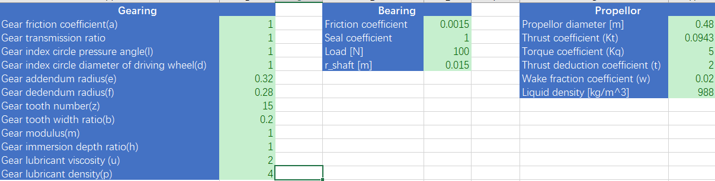

Input a numeric boat speed:

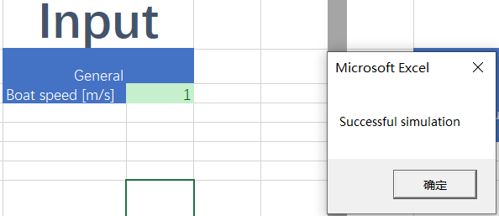

Input a non-numeric value to boat speed:

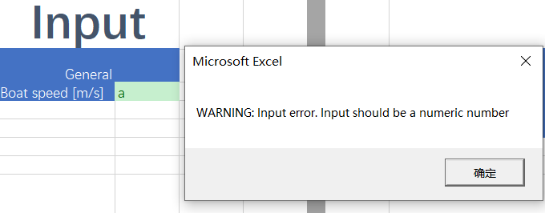

Change some of properties setting values into zero or non-numeric values:

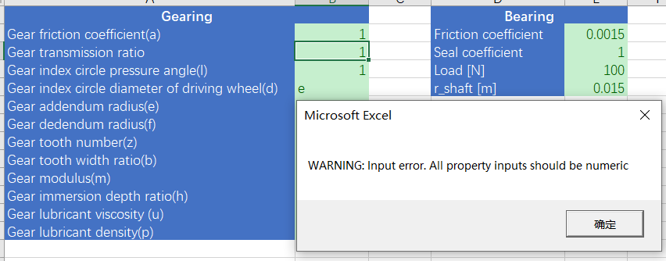

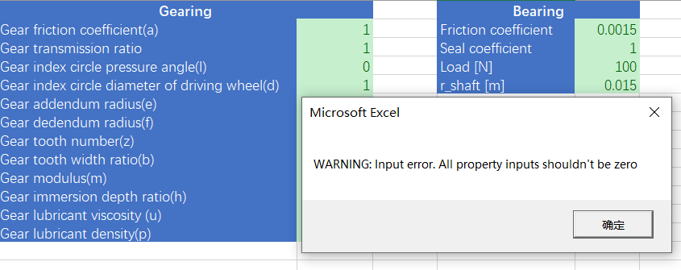

With the setting in step 5, input any value of boat speeds.

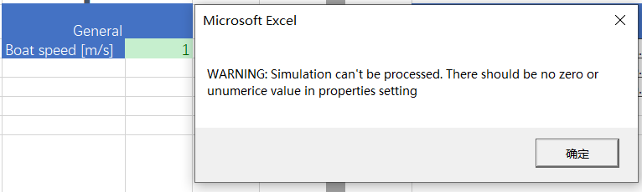

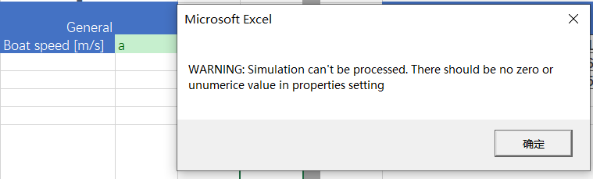

**Conclusion**

The result of this test is same to the desired result list, with different types of inputs, there will be different correct corresponding prompts or warning shown to users. This can remind users the result of simulations and the sources of problems.

|  |  |  |  |
| --- | --- | --- | --- |
| Properties | Boat speed | Message box outputs (In input-output sheet) | Message box outputs (In properties setting sheet) |
| With zero values | No matter what types of value it is. | WARNING: Input error. All property inputs shouldn't be zero | WARNING: Simulation can't be processed. There should be no zero or non-numeric value in properties setting |
| With non-numeric values | WARNING: Input error. All property inputs should be numeric |
| With numeric values | With non-numeric values | - | WARNING: Input error. Input should be a numeric number |
| With numeric values | Successful simulation |